Hi,
I am running simulations of the OC4 SemiSub with different wave directions, and noticed that the platform drift that occurs near a wave period of 7 seconds is always in the positive X direction (pure surge, no sway), regardless of the what the input for WaveDir is (Figures 1 and 2). I would expect the mean drift of the platform to be in the direction of the waves. This seems to be the case for 0 degree wave (Figure 1, Line 2 tension higher), but not for 60 degree wave (Figure 2, would have expected Lines 2 and 3 to have equal higher tensions).
I understand that this mean drift does not occur when DiffQTF/SumQTF (2nd-order forces) are turned off (Figure 3).
Furthermore, when the platform & mooring system are rotated 60 degrees, the platform drifts in the direction of the incident waves (Figure 4) and the results are as expected (Lines 2 and 3 have higher equal tensions).
Figures attached. Can you explain why this behavior would occur in the model?
Thank you so much.
Casey Fontana

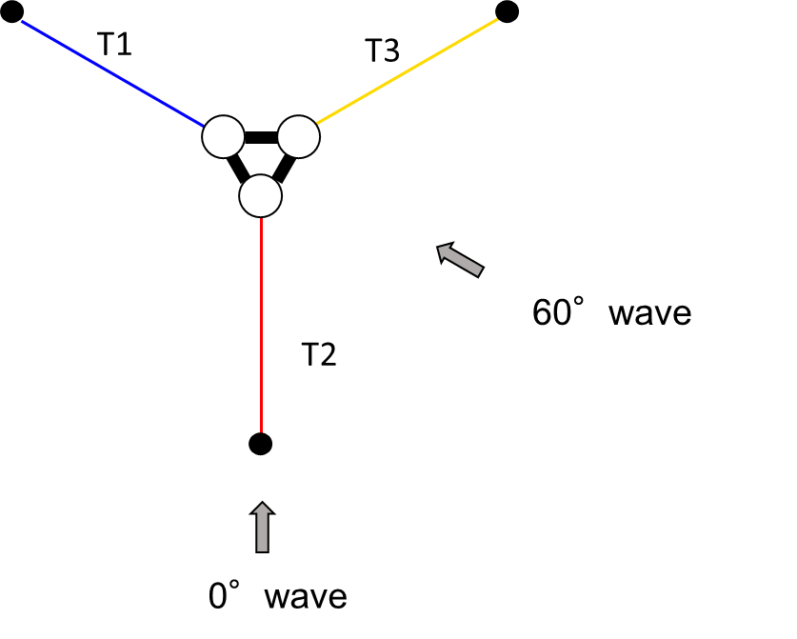
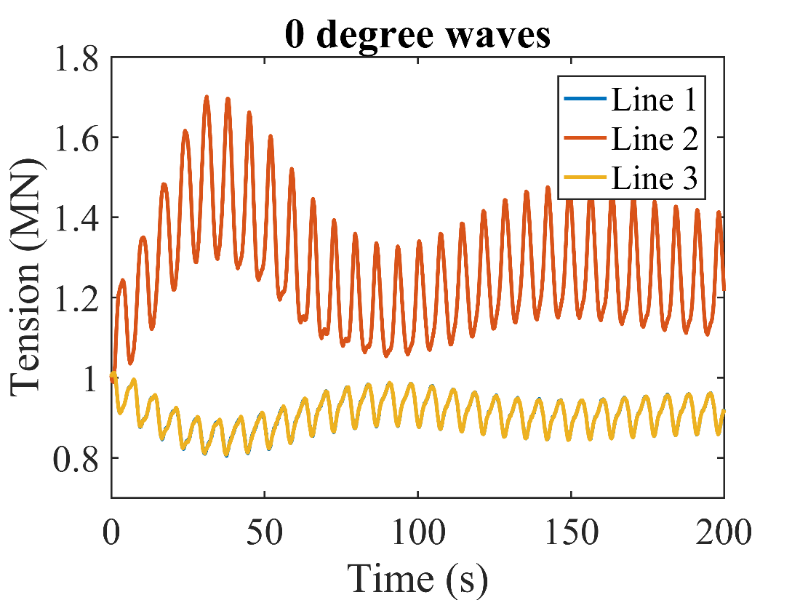
Figure 1: Default semi-sub configuration with 0 degree incident regular waves (H = 5m, T = 7s) and 2nd order forces turned on.

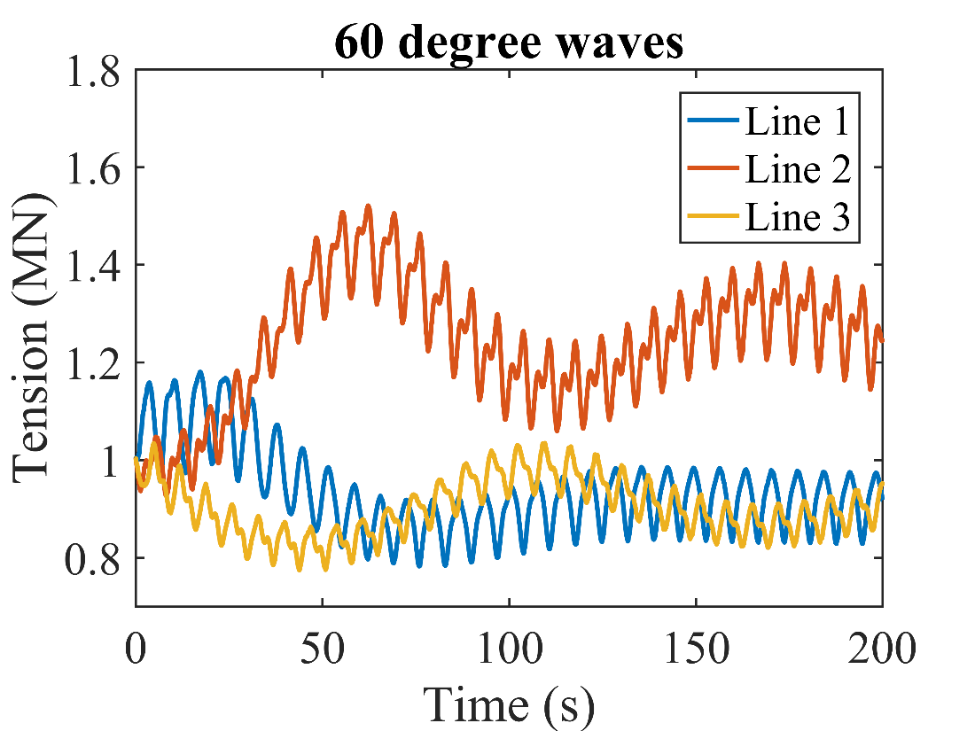
Figure 2: Default semi-sub configuration with 60 degree incident regular waves (H = 5m, T = 7s) and 2nd order forces turned on.

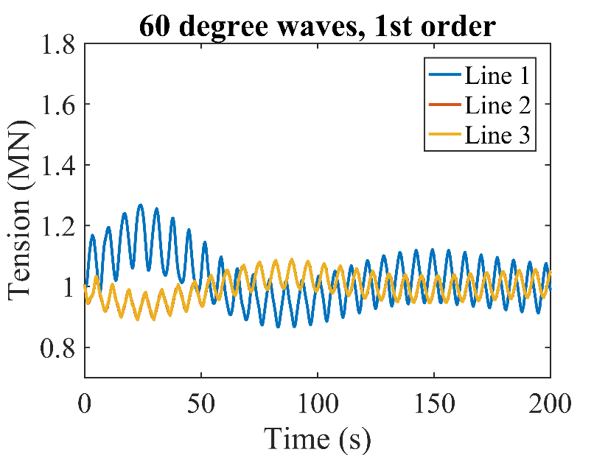
Figure 3: Default semi-sub configuration with 60 degree incident regular waves (H = 5m, T = 7s), and DiffQTF/SumQTF (2nd-order forces) turned off.

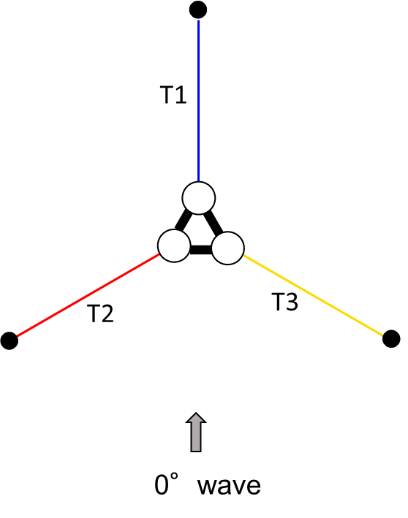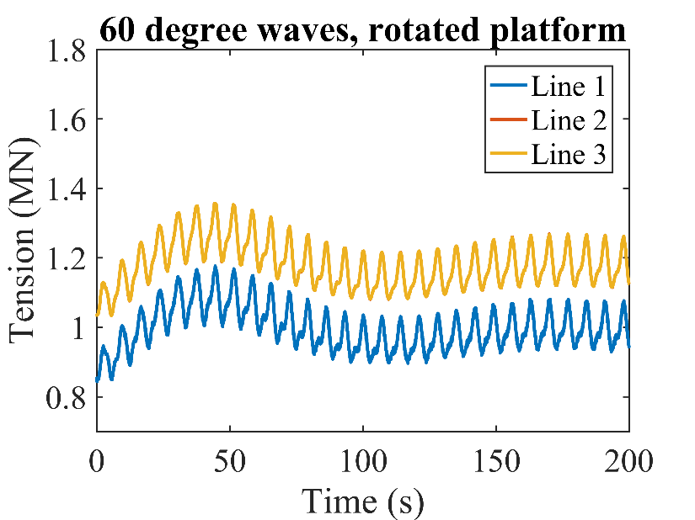
Figure 4: Default semi-sub configuration with 0 degree incident regular waves (H = 5m, T = 7s), 2nd order forces turned on, but the orientation of the platform rotated 60 degrees.

