Dear Jason,

I hope you are well.

I am a FAST user and I met some problems when I used FAST to do some analysis on OC3-Hywind Spar, hoping to get some useful help and suggestions from you.

I used FAST to calculate the coupled dynamic responses of mooring line tension in time domain under the wind and wave load. JONSWAP spectrum and IEC Kaimai model which is calculated in Turbsim are adopted for simulating the random sea state. In the simulation the wind and waves are always from the same direction. I choose some sea state as example as following table list.

|  |  |  |  |  |
| --- | --- | --- | --- | --- |
| Sea state No. | Wind speed | Significant wave height | Peak-spectral period | Spectral bandwidth |
| 22 | 6 | 1 | 6 | 0.999734 |
| 36 | 8 | 1 | 6 | 0.999722 |
| 48 | 10 | 1 | 6 | 0.999560 |
| 60 | 12 | 1 | 6 | 0.998924 |
| 69 | 12 | 7 | 14 | 0.998649 |
| 94 | 18 | 7 | 12 | 0.997909 |

My FAST version is 8.16 and the input files are followed. Please look at the difference input files that I have attached. I have highlighted the terms regarding the various loading condition.

1.Primary Input File

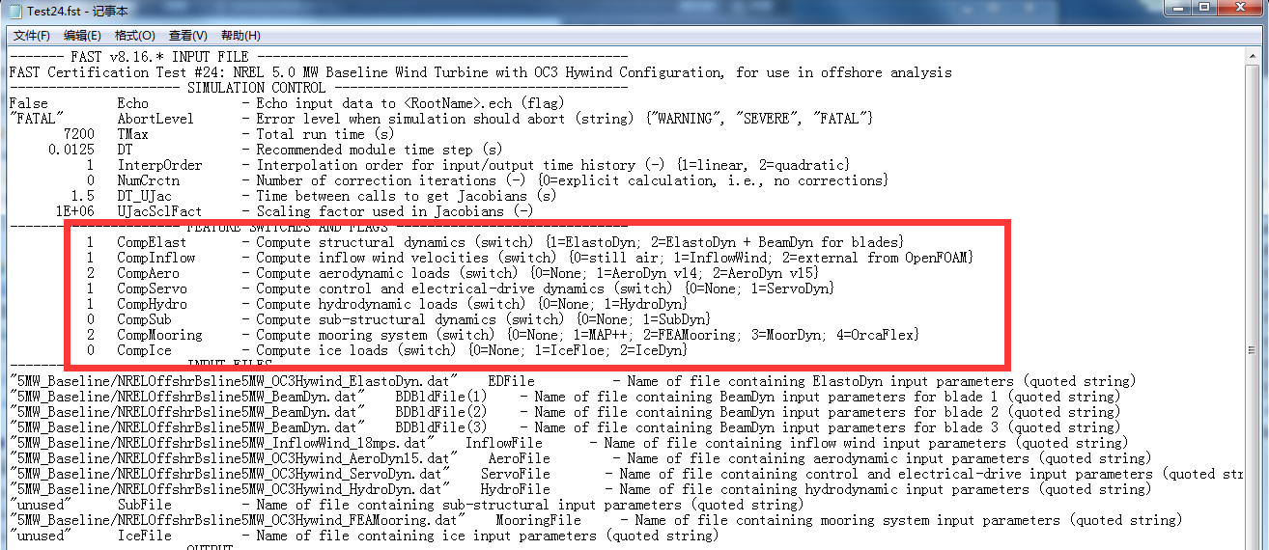

2.Inflowwind input file

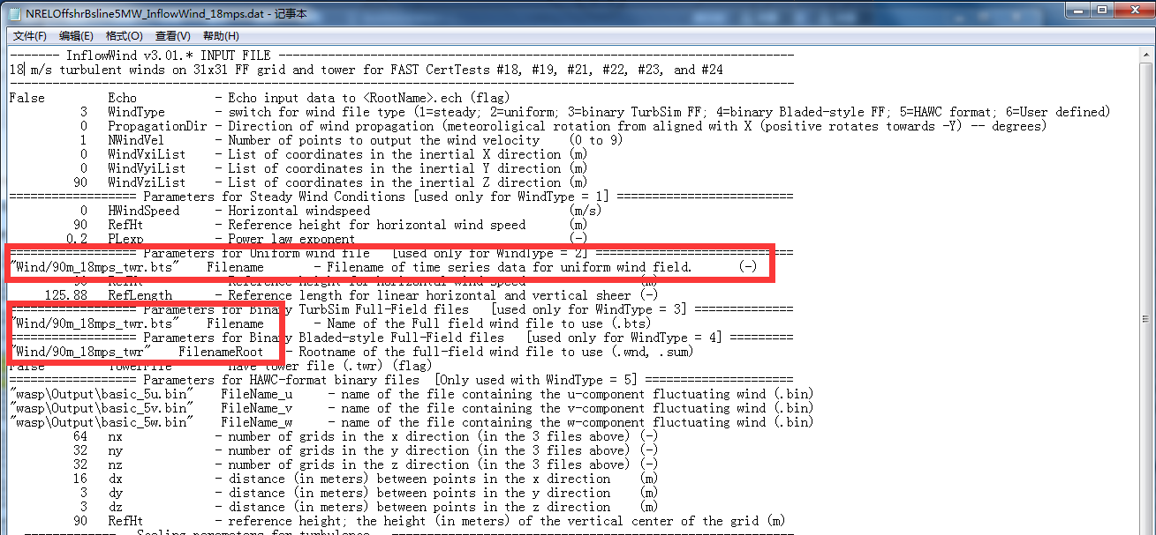

3.Hydrodyn input file

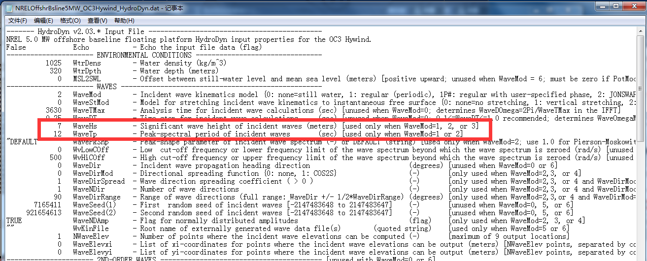

4.FEAmooring file

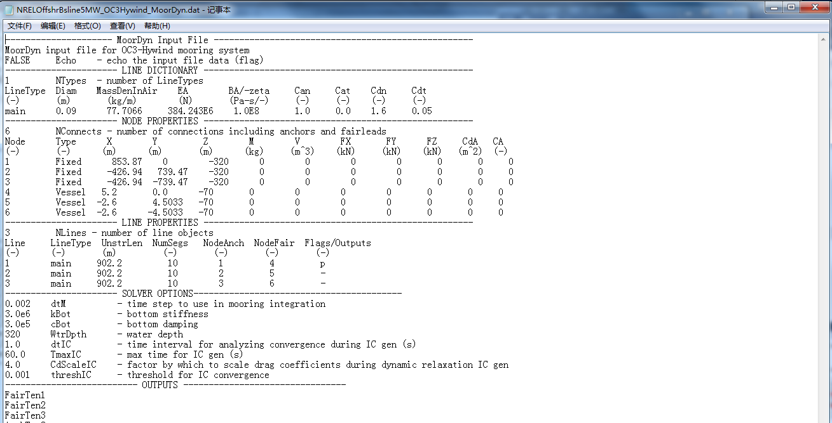

The another file such as ED file and SD file are keep as same as the original set.

The time domain calculation time is 7200s for each sea state and after calculation I do power spectral density(PSD) analysis on the coupled dynamic responses of mooring line tension, the results are as follow:



Sea state No.22 and No.36



Sea state No.48 and No.60



Sea state No.69 and No.94

After comparing the results, I have some problems.

1. No matter how I change the wind and wave load in different sea state, the maximum PSD value occur in almost the same frequency which is at the range of 0.04-0.05rad/s. So I am no sure if the results I calculated are correct and reasonable?
2. The maximum PSD value occur in low frequency which ranged in 0.04-0.05rad/s. The frequency is closed to neither wind frequency or wave frequency. So I feel puzzled by the results and I want you can give me some suggestions.
3. The spectral bandwidth are all very closed to 1 which means it is the wideband, but for each sea state the value of spectral bandwidth is almost the same.so I am not sure about the results.
4. Currently, I have used FAST to calculate totally 100 sea states which are based on the joint distribution model of wind and waves in the Northern North Sea to do a long-term analysis on mooring line tension. In each sea state, I just change the wind file in AD file and wave parameter in HD file, I am not sure if it is correct or not during my calculation. Should I change another parameter ?